**Enlighten Massage Health History & Client Information**

**Contact Information**

Name: **______________________________________** Telephone: **( ) ____________________**

Address: **___________________________________**City/State: **_______________**Zip: **_________**

Referred by: **___________________________________** Telephone: **( ) ___________________**

Emergency Contact: **____________________________** Telephone: **( ) ___________________**

**General & Medical Information**

Occupation: **_______________________________________**Date of Birth/Age: **_________/____**

Physician: **____________________________________** Telephone: **( ) ___________________**

**Please take a moment to carefully read the following information and sign where indicated. If you have a specific medical condition or specific symptoms, massage and bodywork may be contraindicated. A referral from your Primary Care Provider or Physician’s permission may be required prior to service being provided.**

Is this your first experience of a professional massage or bodywork session? Yes / No

If not, how long ago was your last massage and bodywork session?

**Please indicate all of the following that apply to you and if needed, please explain further in the space provided on the next page.**

Acne

Accidents/Injuries (past two years)

AIDS (HIV)

Allergies

Arthritis

Athlete’s Foot

Back pain

Broken bones (past two years)

Bruise easily

Cancer or Tumors

Cardiac/Circulatory problems

Contact Lenses

COVID-19

Diabetes

Dentures

Eczema

Epilepsy or Seizures

Fractures

Frequent Headache

Glaucoma

Heart Disease

Herpes

High Blood Pressure

Hives or Shingles

Impetigo

Instrumentation

Joint Swelling

Kidney Disease

Lung Disease

Neurological Disorder

Numbness/stabbing pain

Osteoporosis

Pregnant (Term: 1, 2, or 3)

Rashes

Sensitive to touch or pressure

Stroke

Thyroid Disorder

Varicose Veins

Any other conditions or contagious diseases:

Comments on conditions:

Please list and describe any medications you are currently taking, as well as any side-effects you are experiencing.

Please explain any major injury or surgical procedure you have experienced, and the approximate date.

Are you currently making routine visits to a Physician, Chiropractor, or Physical Therapist for an ongoing problem? If yes, please explain.

Please rate your current level of stress: (Low) 0 1 2 3 4 5 6 7 8 9 10 (High)

Is stress impacting your health and wellness? If yes, in what ways?

What types of exercise do you engage in and how often?

What is your primary pain complaint or area of focus in this moment?

What are your goals in receiving massage therapy and bodywork?

Please indicate on the human diagrams below where you are feeling:

A=Aches, N=Numb, P=Pain, S= Sore, ST=Stiff, T=Tingling, Other: _____=____________

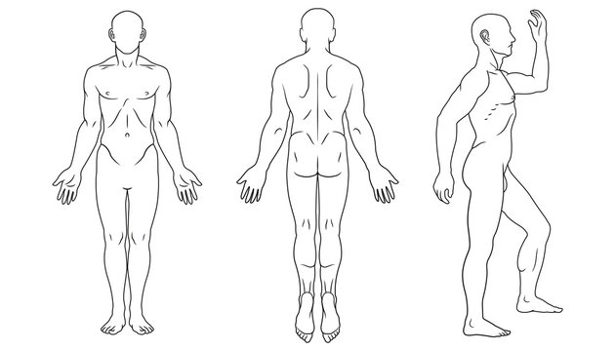

I understand that the massage and bodywork I receive is provided for the basic purpose of relaxation and relief of muscular tension. If I experience any pain or discomfort during a session, I will immediately inform the Practitioner so that the pressure and/or strokes may be adjusted to my level of comfort. I further understand that massage and bodywork should not be construed as a substitute for medical examination, diagnosis, or treatment, and that I should see a Physician, Chiropractor, Counselor, or other qualified specialist for any mental or physical ailment of which I am aware. I understand that Massage and Bodywork Practitioners are not qualified to perform spinal or skeletal adjustments, diagnose, prescribe, or treat any physical or mental illness, and that nothing said in the course of any session provided should be construed as such. Because massage and bodywork should not be performed under certain medical conditions, I affirm that I have stated all of my known medical conditions, and answered all questions honestly. I agree to keep the Practitioner updated as to any changes in my medical profile and understand that there shall be no liability on the Practitioner’s part should I fail to do so. I also understand that any illicit or sexually suggestive remarks or advances made by me will result in immediate termination of the session, and I will be liable for full payment of the scheduled appointment.

**Signature: _________________________________________________________ Date: ____________**

***Consent to Treatment of a Dependent:*** By my signature below, I hereby authorize Licensed Massage Therapist and Bodywork Practitioner Melissa Raml of Enlighten Massage to administer massage, bodywork, or somatic techniques to the dependent under my care.

**Signature of Legal Guardian: _______________________________________ Date: _____________**